**PROJECT – 1**

**Deploying Web Server in Windows Instance:**

**Task 1:** Create a window instance using AMI Window 2012 R2 Base.

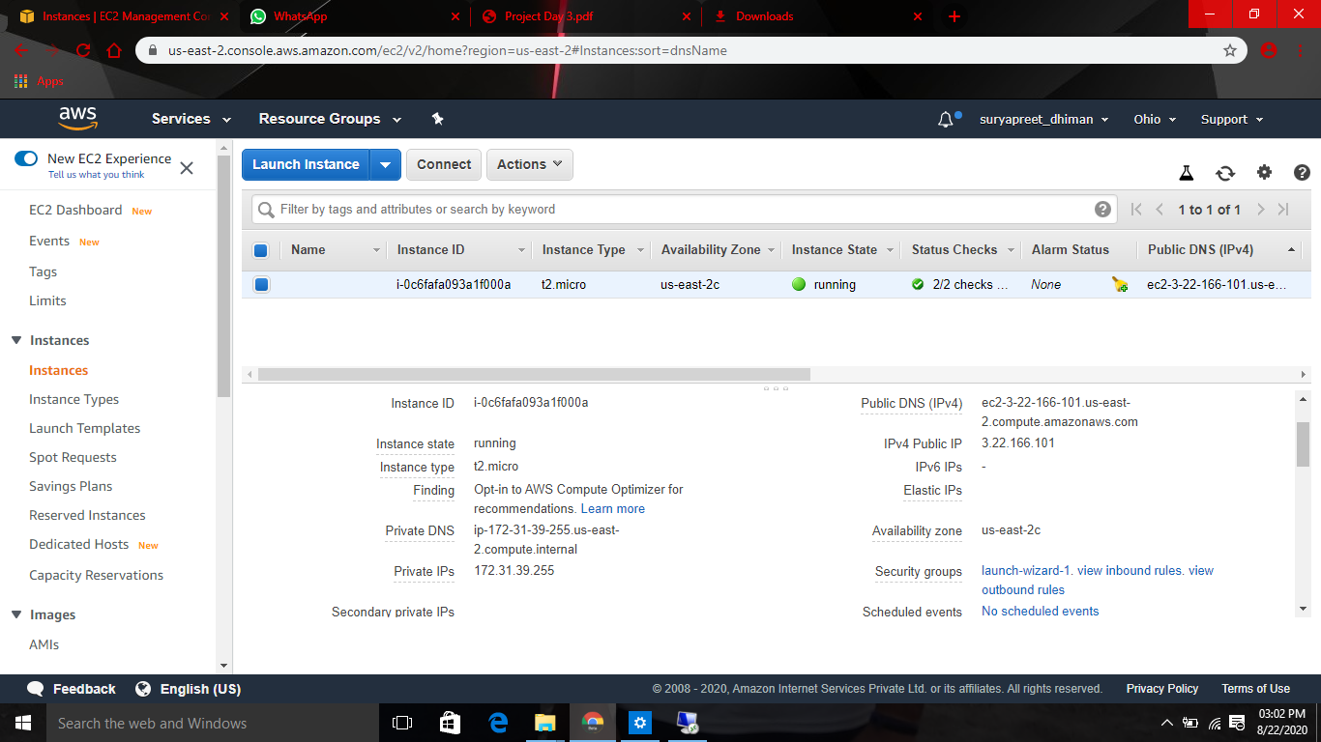

**Task 2:** Launch the Window Instance using RDP File.

**Task 3:** Install IIS Web Server using Powershell ISE.

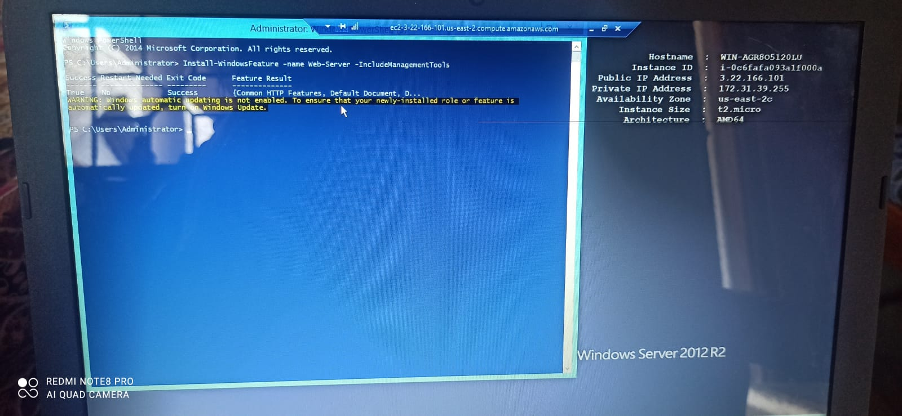

**Task 4:** Verify successful installation of IIS Web Server.

